Blairdaff and Chapel of Garioch Parish Church
Sunday 5th April 2020
Sadly, we cannot meet together today. However, we are able to worship together by using the devotions below.

Welcome
Today is Palm Sunday. We remember Jesus’ triumphal entry into Jerusalem.

Zechariah 9:9
Rejoice greatly, Daughter Zion!
Shout, Daughter Jerusalem!
See, your king comes to you,
righteous and victorious,
lowly and riding on a donkey,
on a colt, the foal of a donkey.

Song: Come, now is the time to worship Click on the link

Prayer

Almighty Father, on the first Palm Sunday your Son, Jesus Christ,
entered the city where he was to die. By your Holy Spirit enter
our hearts and make them your own. As Jesus’ disciples blessed
his coming by spreading garments and branches across his path,
make us ready to lay at your feet all that we have and are,
that we too may bless Christ’s coming as our Lord and Saviour.
Lord God, today we wave our palms and shout our praise to your Son, Jesus our Lord, yet we find it hard to praise you for the blessing you give to us every day. Forgive our selfishness and greed.

Lord God, today we lay our coats at Jesus’ feet, but forget that Jesus died upon and cross and rose again so our sin would be forgiven, and the gates of heaven opened to us. Forgive our laziness and neglect.
Lord God, today we shout “hosanna” to the King of kings, but we neglect to praise him every day and we forget that every day you call us to take up our cross and follow him. Forgive us our erratic recognition of Jesus’ reign in our lives.

Lord God grant us your forgiveness and bring us pardon and peace. Ride into our hearts as Jesus rode into Jerusalem. We pray in his name saying together the prayer he taught:
Our Father who art in heaven, hallowed be thy name;
thy kingdom come; thy will be done;
on earth as it is in heaven.
Give us this day our daily bread.
And forgive us our debts, as we forgive our debtors.
And lead us not into temptation; but deliver us from evil.
For thine is the kingdom, the power and the glory,
for ever. Amen.

Song: King of Kings, majesty Click on the link

A Prayer for this time of Coronavirus

God of love and hope,
you made the world and care for all creation,
but the world feels strange right now.
The news is full of stories about Coronavirus.
Some people are worried that they might get ill.
Others are anxious for their family and friends.
Comfort the families of those who have died.
Be with them and help them to find peace.
Protect all who must work in close proximity to others particularly those who are caring for people frail and unable to care for themselves.
We pray for the doctors and nurses and scientists,
and all who are working to discover the right medicines to help those who are ill.
We ask for your blessing, guidance and gifting for those who are turning industrial production away from their usual products to make ventilators, sanitisers and other types of equipment and products.
Thank you that even in these anxious times, you are with us.
Help us to put our trust in you and keep us safe. Amen
(Adapted from Church of England website)

Bible Passage

Jesus’ triumphal entry into Jerusalem, a week before his crucifixion and resurrection, began near Bethphage and Bethany, three to four miles from Jerusalem. It was in Bethany that Jesus had raised Lazarus from the dead. That miraculous act that had given Jesus a following. John writes, “The crowd that had been with him when he called Lazarus out of the tomb and raised him from the dead continued to bear witness. The reason why the crowd went to meet him was that they heard he had done this sign.” (John 12:17-18) It was also at Bethany that Mary anointed Jesus with pure nard, wiping his feet with her hair, just a day before the procession.

Jesus went on in front of them toward Jerusalem. ²⁹ As he came near Bethphage and Bethany at the Mount of Olives, he sent two disciples ahead ³⁰ with these instructions: “Go to the village there ahead of you; as you go in, you will find a colt tied up that has never been ridden. Untie it and bring it here. ³¹ If someone asks you why you are untying it, tell him that the Master^{[a]} needs it.”
³² They went on their way and found everything just as Jesus had told them. ³³ As they were untying the colt, its owners said to them, “Why are you untying it?”
³⁴ “The Master needs it,” they answered, ³⁵ and they took the colt to Jesus. Then they threw their cloaks over the animal and helped Jesus get on. ³⁶ As he rode on, people spread their cloaks on the road.
³⁷ When he came near Jerusalem, at the place where the road went down the Mount of Olives, the large crowd of his disciples began to thank God and praise him in loud voices for all the great things that they had seen: ³⁸ “God bless the king who comes in the name of the Lord! Peace in heaven and glory to God!”
³⁹ Then some of the Pharisees in the crowd spoke to Jesus. “Teacher,” they said, “command your disciples to be quiet!”
⁴⁰ Jesus answered, “I tell you that if they keep quiet, the stones themselves will start shouting.”

Luke Ch19 v28-40

Listen to the symbols
On the face of it, Jesus’ entry into Jerusalem was a jolly celebratory procession much like we might see at a carnival. We often hold processions, often to celebrate a victory, like a Scottish FA cup win. You’ll remember the Olympic flame was processed around the country before the 2012 London Games. Perhaps you also remember the Queen’s jubilee procession.
Jesus’ entry into Jerusalem might not have been quite as grand, but it was one of two processions that would have drawn the attention of Jerusalem in those days just before Passover.
To fully grasp what was going on we need to understand the meaning of the symbols associated with the whole event.

It’s called Palm Sunday; that’s because John records that people, “took palm branches and went out to meet him” (John 12:13) Palms were a national symbol of Israel, just like the Scottish thistle or Welsh leek. Images of palms were on Israel’s coinage.
In Psalm 92: 12-13 we read; “The righteous flourish like the palm tree and grow like a cedar in Lebanon. They are planted in the house of the Lord; they flourish in the courts of our God.” Palm trees had longevity and symbolised permanent security enjoyed by the faithful. “They flourish in the courts of our God” indicates prosperity and lasting residence in God’s presence.
Those who spread palms on the road were making a nationalistic and political statement, “this is our King, the King of the Jews.” Indeed, John records the shouts of, “Blessed is the King of Israel!” (John 12:13). The waving of palms also had a historical context. When Judas Maccabaeus defeated pagan invaders and cleansed the Temple in 164BC his followers entered Jerusalem waving palm branches in celebration; an event remembered to this day, known as Hanukkah. So, the waving of palms conveyed the idea of victory.
Matthew, Mark and Luke record the crowd carpeting the road with their cloaks, suggesting people regarded this as a royal procession. When Jehu was made King of Israel we read; “They hurried and took their cloaks and spread them under him on the bare steps. Then they blew the trumpet and shouted, ‘Jehu is King.’” 2 Kings 9:13 | 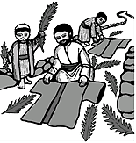
Jesus’ steed was a colt, according to Matthew, Mark and Luke. It had never been ridden, implying a purity that in Old Testament scripture destined an animal for a sacred task (see Numbers 19:2 and Deuteronomy. 21:3). Matthew 21:2 mentions that it was the colt of a donkey; John, that Jesus found a young donkey and sat on it, consistent with the prophecy of Zechariah 9:9 that we read at the beginning of this service. Donkeys were animals of peace in contrast to the war horse. Jesus procession would have been in great contrast to that of Pilate’s when he entered Jerusalem for the Passover festival. The Roman Governor of Judea, resided in the provincial capital of Caesarea Maritima, a coastal town in the north. So, each year, just before Passover, Pilate would travel south to Jerusalem. As a show of Roman strength and domination he would come with cavalry horses, the sound of clinking of bridles, the beating of drums, and the rhythmical crunch of a marching army, striking fear into the city’s inhabitants and all who had come for Passover.  Jesus, by contrast, would establish his Kingdom not by violence, fear and oppression but by courageous acceptance and love of all, a servant King - taking his place among the victims of imperial power. | 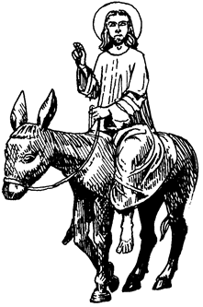
The crowd shouted, “Hosanna!” a Hebrew expression meaning “to save”. It also had connotations of praise. The crowd were praising Jesus as the one who would come and save them. Some might have grasped exactly what this meant, others anticipated being saved from the Romans and that Jesus was about to instigate a military coup against them establishing Israel’s political and military dominance.  They also shouted; “Blessed is he who comes in the name of the Lord”, evoking the sentiments of Psalm 118:25-26:  “Save us, we pray, O Lord!  O Lord, we pray, give us success!  Blessed is he who comes in the name of the Lord!  We bless you from the house of the Lord.”  They were identifying Jesus with one sent by God to help defeat their enemies. | Hosanna!  Blessed is he who comes in the name of the Lord!

Clearly, the actions and shouts of the crowd would have put the Roman authorities on alert. The Passover festival, with is historic origins in the Exodus, always had nationalistic overtones and was always a time when these could spill over into riot and insurrection. Jesus’ triumphal entry into Jerusalem would have only heightened the tensions.

Take a stand
The procession must have a caused quite a stir. It began outside the city moving right into its heart. There were those who would have travelled with Jesus from Bethany and others who lined the road as he entered the city because they’d heard about the raising of Lazarus. They wanted to see this spectacle. If this Jesus can raise a man from the dead he could free them from Roman oppression.

Others wanted to stop the procession, calling to Jesu;. “Teacher, rebuke your disciples.”

So, what are we to make of this triumphal entry? The question to ask is, “where do I stand on this day of palms?”

Do I stand with my back to the road, not even curious? Once it’s all over I’ll give it no thought at all and simply return to my life the way it was.

Perhaps I stand in the way, trying to stop the procession and the cries of “Hosanna!”? Am I frightened about how it might end? Do I think it dangerous that this Jesus is treated as a king? Am, I concerned that it will up-set the status quo, challenging ideas, attitudes and values making the world a different place? Then what of my place in that new world? Will my status, wealth, influence, be affected, diminished? Aren’t the Pharisees, learned, respected, upholders of the law, right to bring this to an end?

Perhaps I’m one of those who stands at the back of the crowd, looking on, distanced from the event? For a moment, a glimpse and then his gone. Not getting too involved. That’s for others. I don’t want to be shaken out of my comfort zone and forced to reassess all that I am including my relationship with God.

Do I stand on the roadside getting caught up in the procession? With others in the crowd do I tear down a branch to carpet the road, excited for a moment … but then drift away, back to my world as it was - unmoved, unaffected, unchanged.

Or do I stand with Jesus’ disciples and followers shouting “Hosanna to the Son of David! Blessed is he who comes in the name of the Lord” certain in the knowledge that Jesus is my Lord, and King of my heart, where I live in his service day by day; a soldier of Christ, strong in the strength which God supplies through his eternal Son, following him to Jerusalem, a new Jerusalem, a city where angels sing his praise?

The other procession this week will be on Friday. That one will start in the heart of city and move to a hill just outside. Where will I stand then?

Prayer:
True and humble king,
hailed by the crowd as Messiah:
grant me the faith to know you and love you,
that I may be found beside you
on the way of the cross,
which is the path of glory. Amen. (Alternative Collect for Palm Sunday)
Hymn: You are the King of Glory Click on the link
Poem: Palm Sunday – Acrostic Poem written by a Primary 5 class.
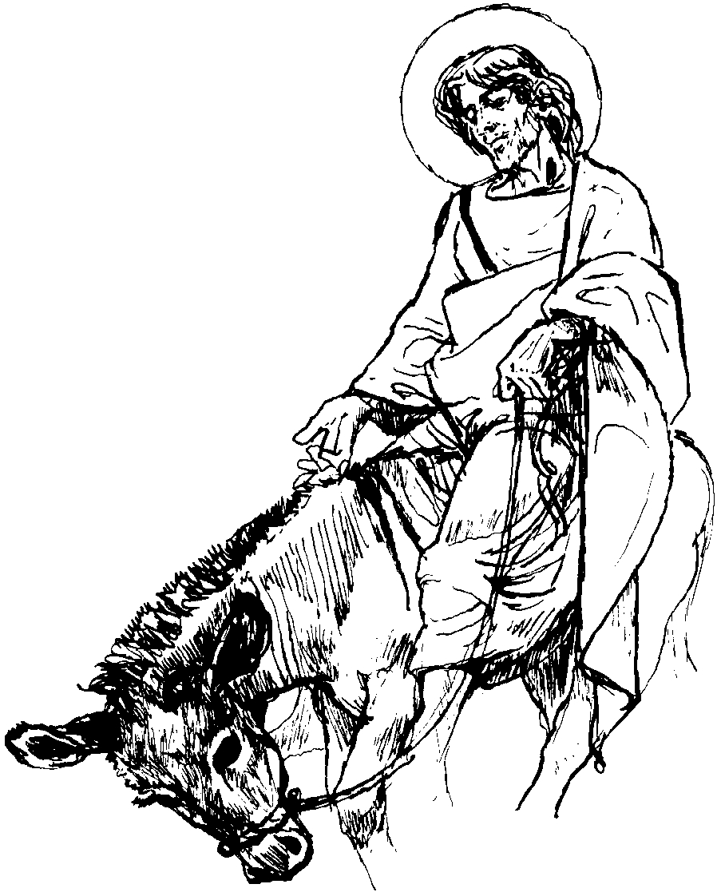
Praises shouted for Jesus,
Along the dusty road,
Lined the crowd of people,
Most of them waving palms,
Singing their welcome,
Unfortunately, Jesus began to cry,
Never believing He would die,
Disciples by his side,
Angry voices would soon shout,
You will be CRUCIFIED!
Prayers of the People for the People

Lord Jesus, the servant king, you humbled yourself on a donkey.
We pray for your church; rid us of our pride, make us more
humble, willing to share, and help us to know the joy that comes
from living our lives in your service.

We pray for opportunities and courage to spread your good news.
Just as the crowds welcomed you and sang your praises we pray
that many more will welcome you into their hearts and lives.

Lord Jesus, you rode straight into the enemy to suffer and die that your faithful people might have everlasting life at one with God the Father.
Lord Jesus, there are those who stand looking on but fail to recognise you.
May your glory be revealed to them.
There are those who look and turn away rejecting you.
May their hearts be turned towards you.
Ride through our communities and ride through our hearts; that we may always proclaim you as King of kings and Lord of lords.

Lord Jesus, you entered Jerusalem not upon a war horse but on a donkey, a symbol of peace. We pray for all for whom the ways of peace are hidden from their eyes and who seek the ways of war and violence. We bring before you the people of the war-torn areas of this world and all who live in fear of violence and conflict. Prince of Peace may your will be done on earth as it is in heaven. Give courage and strength to all who work for peace and justice, give them the confidence to confront power with love.

Guide the rulers of earthly kingdoms as they take decisions which affect everyone in the world. May they govern with humility, understanding their role as servants of those they represent. May posturing be replaced with action that improves peoples’ lives, and jockeying for position replaced with genuine efforts to feed the hungry, clothe the naked and care for those who are weak, exploited or abused.

Lord Jesus, the crowds were responding to the healing love they had seen in you. You are the King who, made the lame to walk, the blind to see, cast out devils, befriended sinners and raised the dead. We bring to you people sick, lonely or downcast. May they feel you take their hand giving them comfort, reassurance, wholeness and hope.

Lord Jesus, the children sang and shouted your praise. We pray for the children in our homes and across our land; may we not fail them in the support and teaching they need. Neither may we fail the children born in far off places living with hunger, exploitation, or sickness.

Lord Jesus, you knew you were riding to your death. We pray for all on that last journey, especially those burdened with fear and guilt. We thank you that through faith in you the gates of the Kingdom are opened enabling us to live at one with you for ever.

We too, spread our coats on the road in an act of homage as we express our thankfulness for all you have done for us and the amazing extent of your love. Amen.

Benediction and Blessing

True and humble king,
hailed by the crowd as Messiah:
grant us the faith to know you and love you,
that we may be found beside you on the way of the cross,
which is the path of glory.

Blessing click on the link

x x x x

One of the consequences of us not being able to worship together is that the church
anticipates a fall in income. However, we will continue to incur costs, of insurance
etc. There will be little financial saving to our not meeting, yet revenues could be
severely hit. Please prayerfully reflect on this and, if you are able, continue to put aside
your financial offering so that you can make your contribution for the work of the church
when we next meet together. Thank you.
Thank you too if you already give by standing order or by bank transfer, that is much
appreciated.

